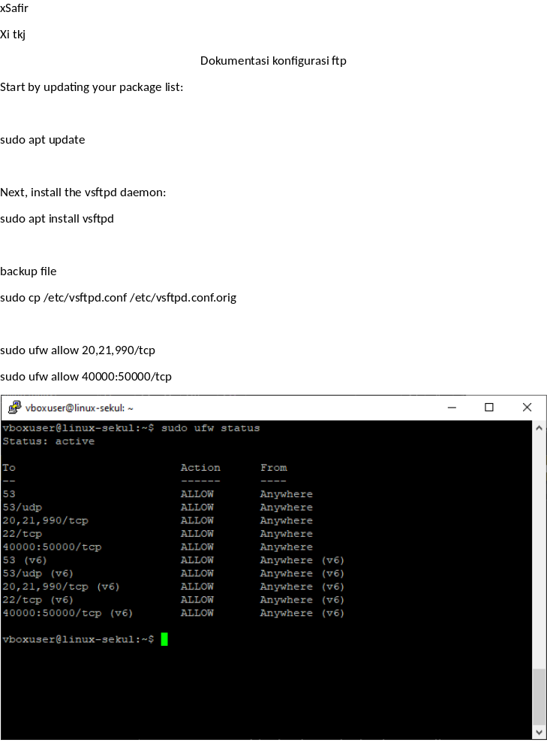xSafir
Xi tkj
Dokumentasi konfigurasi ftp
Start by updating your package list:

sudo apt update

Next, install the vsftpd daemon:
sudo apt install vsftpd

backup file
sudo cp /etc/vsftpd.conf /etc/vsftpd.conf.orig

sudo ufw allow 20,21,990/tcp
sudo ufw allow 40000:50000/tcp
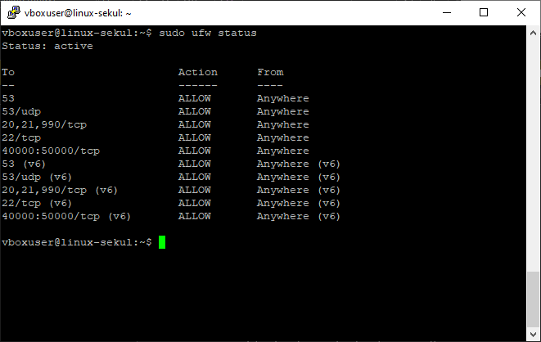

Tambahkan user
sudo adduser [nama]

set owner file dan group
sudo chown ftpuser:ftpuser /home/ftpuser/ftp
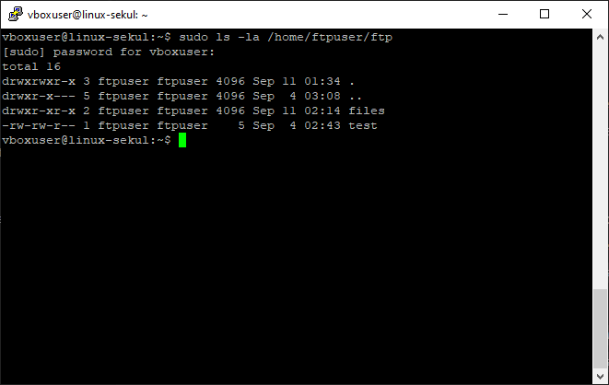

Konfigurasi ftp akses
sudo nano /etc/vsftpd.conf

anonymous_enable=NO
local_enable=YES
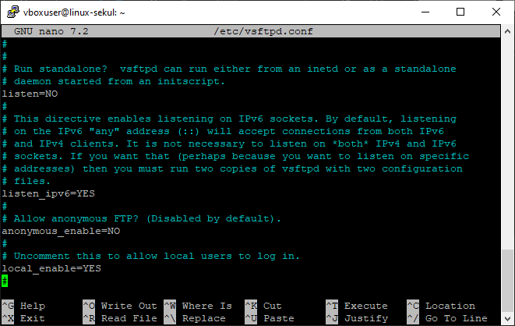

Tambahkan chroot_local_user=YES
agar peguna ftp tidak bisa akses diluar directory yang di tentukan
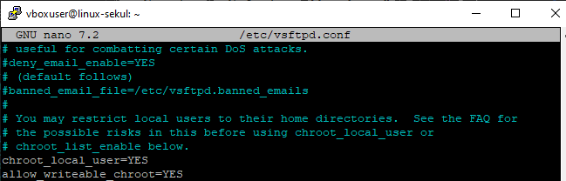

user_sub_token=$USER
local_root=/home/$USER/ftp
untuk menentunkan home directory user ftp saat login

pasv_min_port=40000
pasv_max_port=50000
nentuin rentang port yang dipakai mode passive ftp

userlist_enable=YES
userlist_file=/etc/vsftpd.userlist
userlist_deny=NO
untuk list user mana yang punya akses gunakan ftp

userlist_deny=yes
untuk lis user mana yang gaboleh gunakan ftp

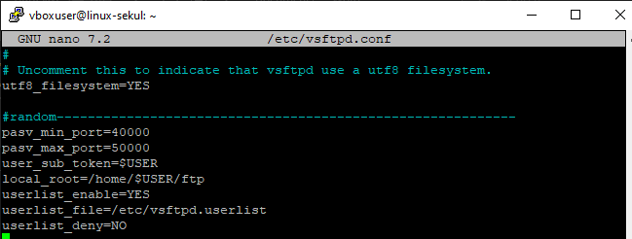

Tambahkan user ke list
Cek user yang sudah di list dengan :
cat /etc/vsftpd.userlist

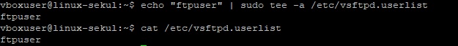

5. konfigurasi ssl
sudo openssl req -x509 -nodes -days 365 -newkey rsa:2048 -keyout /etc/ssl/private/vsftpd.pem -out /etc/ssl/private/vsftpd.pem

You’ll be prompted to provide address information for your certificate. Substitute your own information for the highlighted values:

Generating a 2048 bit RSA private key
............................................................................+++
...........+++
writing new private key to '/etc/ssl/private/vsftpd.pem'
You are about to be asked to enter information that will be incorporated
into your certificate request.
What you are about to enter is what is called a Distinguished Name or a DN.
There are quite a few fields but you can leave some blank
For some fields there will be a default value,
If you enter '.', the field will be left blank.

Country Name (2 letter code) [AU]:
State or Province Name (full name) [Some-State]:
Locality Name (eg, city) []:
Organization Name (eg, company) [Internet Widgits Pty Ltd]:
Organizational Unit Name (eg, section) []:
Common Name (e.g. server FQDN or YOUR name) []:
Email Address []:

Konfigurassi
sudo nano /etc/vsftpd.conf

(sertifikat test/dummy)
rsa_cert_file=/etc/ssl/certs/ssl-cert-snakeoil.pem
rsa_private_key_file=/etc/ssl/private/ssl-cert-snakeoil.key

(tempat file sertifikat dan kunci)
rsa_cert_file=/etc/ssl/private/vsftpd.pem
rsa_private_key_file=/etc/ssl/private/vsftpd.pem

ssl_enable=YES(aktifkan ssl)

allow_anon_ssl=NO (gaboleh anonym)
(wajib pakai ssl)
force_local_data_ssl=YES
force_local_logins_ssl=YES

(mengaktifkan protokol tlsv1 dan menonaktifkan sslv agar aman)
ssl_tlsv1=YES (enkripsi)
ssl_sslv2=NO
ssl_sslv3=NO

require_ssl_reuse=NO (tidak wajib gunain session ssl sebelum nya)
ssl_ciphers=HIGH (cuman pakai enkripsi kuat)
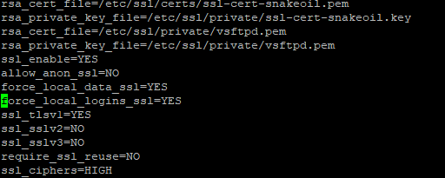
Restart service
sudo systemctl restart vsftpd

